Types of Data:

1.bool
2.complex
3.int
4.float
5.str

Collections of different datatypes: (Tell difference based on order ,duplicates, index, slice, changes)
1.list : l= [ True, 10+20j, 10, 10.1, ’Chetan’ ,10]
2.tuple: t= (10,20,30)
3.set : s= {10,20,30}
4.dict : {100:’Chetan’,200:’Shekdar’}
5.range

- List :
- Order preserved
- Duplicates objects are allowed
- Heterogenous objects are allowed
- Indexing & slicing concepts are available
- l.append, l.remove options are available (Growable in nature)
- List is mutable. We can modify list

- Tuple :
- All properties of list are applicable to tuple, except mutable.
- Tuple is immutable. We can’t modify tuple(add, remove not applicable)
- Read only version of list is tuple.

- Set :
- Order is not important, therefore slicing & indexing not applicable.
- Duplicates are ignored and gives the output.
- E.g S= {1,2,3,1} output= {1,2,3}
- S.add & s.remove applicable (Growable in nature)
- Set is mutable. We can modify set
- S= set() Creating empty set.

- Dict : Group of objects as key value pair. (word: meaning)
- By default empty {} is dict not set.
- Representation d= {key1:value1,key2:value2}
- Order is not important in dict.
- Duplicate Keys are not allowed (if used old value is replaced with new value) , but values are allowed.
- Heterogenous objects are allowed
- Dict is mutable.
- Dict is accessed by using keys.

- Range :
- R= range(end) # by default begin=0)
- R= range(begin, end)
- R= range(begin ,end, increment/decrement)
- Order, index, slicing available
- Can’t modify range. i.e immutable
- Heterogenous objects are not allowed

Escape Characters:
\n= new line
\t= horizontal tab
\r= carriage return
\b= backspace character

OOP in Python:
Class: It acts as blueprint for objects/plan/design/model.
Object: Instance of a class
Reference Variable: Physical instance of class

class Student: Class
def __init__(self,name,age): Constructor
self.name= name
self.age= age Instance variables

def getInfo(self): Method of the class
print("Student Name is:", self.name)
print("Student Age is:", self.age)

s= Student('Chetan',29) “ S “ is a reference variable (Equivalent to the “ self “)
s.getInfo()

self :
Inside of the class compulsory we need self, to access instance var’s. Outside of the class self won’t work. We need reference variable.
Using self we can access instance var’s and instance methods. Self should be first parameter inside constructor and methods.
class Test:
def __init__(self):
print('Inside', id(self))
t= Test()
print('Outside', id(t))

Output:
Inside 1876460438864
Outside 1876460438864
- The “self” & “t” objects are referring same objects( same address).

def __init__(self):
- Constructor will be executed automatically at the time of object creation
- The purpose of the constructor is to declare instance variables and to perform initialisation.
self.name= name (declaring instance var)
self.age= age (declaring instance var)

Difference between Method & Constructor:

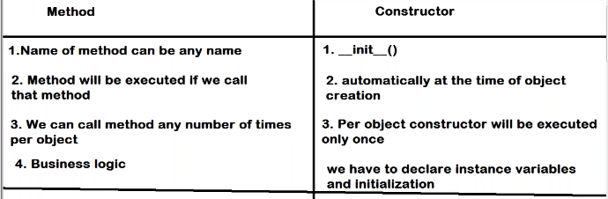

Types of variables:

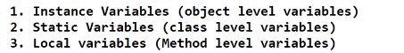
- Instance Variables:
- If the values of the variables varied from objects to objects then such type of variables are called as Instance variables or Object level variables.
- Usually, we can declare instance variables inside the constructor.
- At the time of object creation instance variables created.
- For every object a separate copy of instance variables will be created.
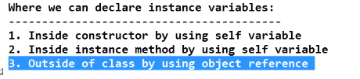
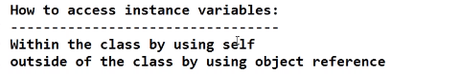
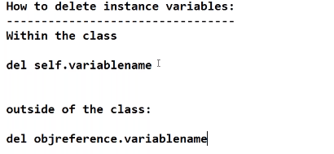

- Static Variables: (self & cls is not required)

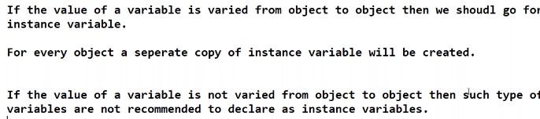

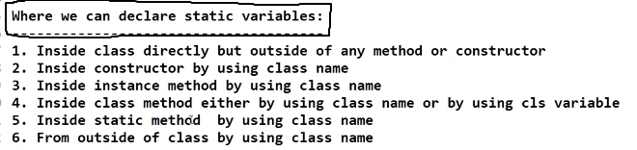

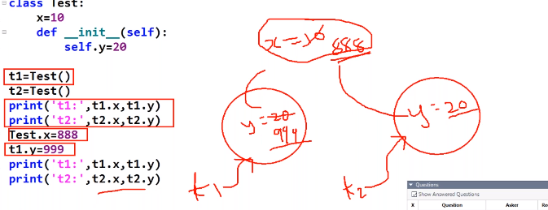

Difference between Instance Variable & Static Variable:
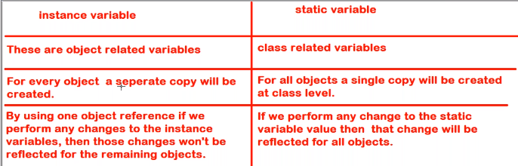

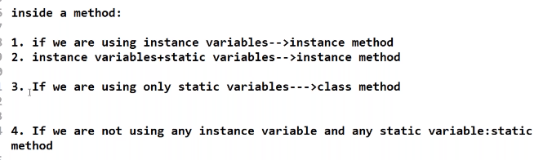
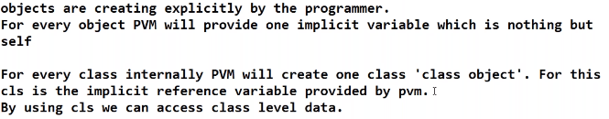

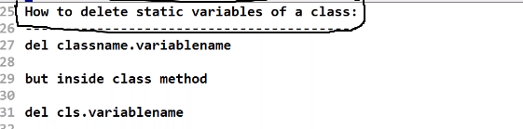
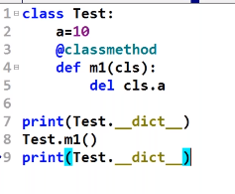
- Local Variables:
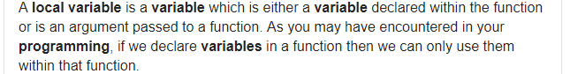

Types of Methods:

- Instance Methods:
- Whenever we are talking about Instance method compulsory, we must talk about
- A. Setter Method and B. Getter Method
- Purpose of these two methods:
- Setter method can be used to set value to the Instance variables.
- 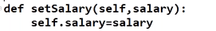
- Getter method can be used to get value of instance variable. Return is mandatory
- 
- Setter & Getter methods are instance methods. Those are used when data is not available at the beginning .
- Summary: When we should go for IM?

- Class Methods:
Summary: When we should go for CM?
- We have to use @classmethod decorator explicitly
- We can call CM either by using class name or object reference. Recommended is class name.
- Example:
- For class method decorator is mandatory. If we are not using any decorator, it will be either IM(if we called using object reference) or SM (if we called using class name)

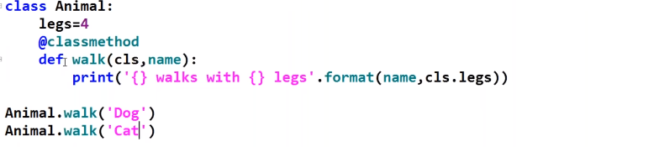
- Here we are only using class variable. We are not using Instance variable at all.
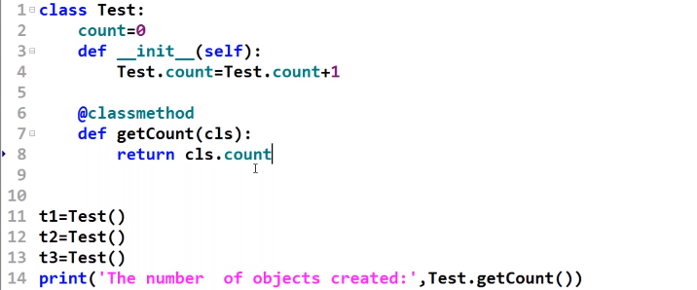

- Static Methods:

- It never talks about Instance variable & Class variable.
- In this, no need to create object. We can directly call classname.method
- For static method decorator is optional.
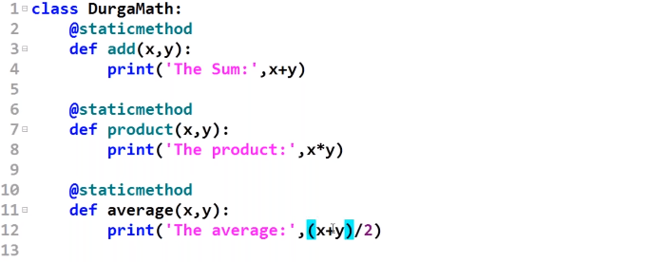

Difference between 3 methods:

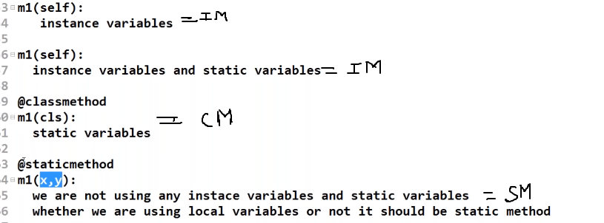

Types of Class:

- Assessing member of one class inside the other class.

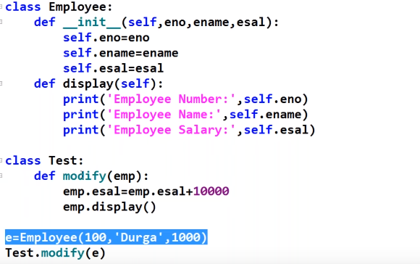

- By Composition (Has- a relationship)- Code Re-usability

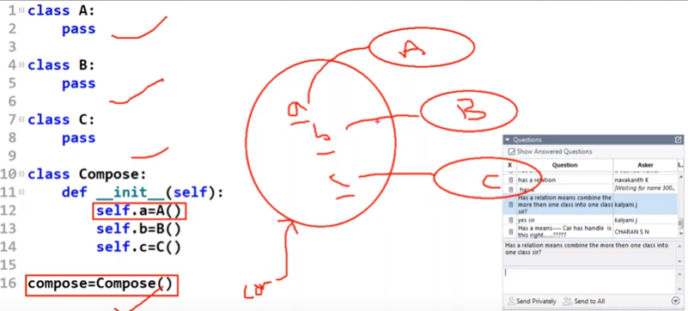

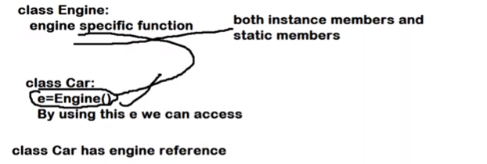

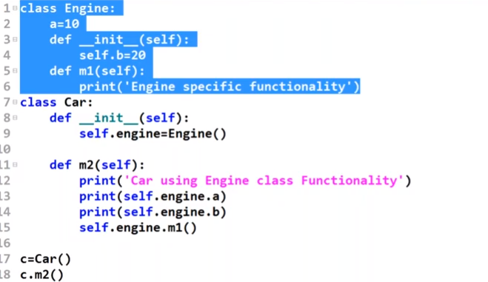

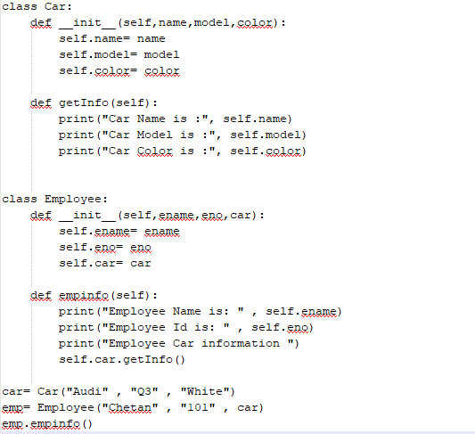

- By Inheritance (Is- a relationship)- Code Re-usability

- If we want to extend exiting functionality with some more extra functionality then we should go for Inheritance.
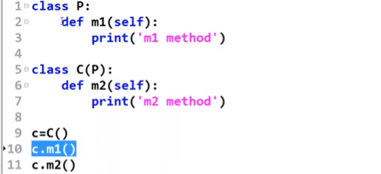

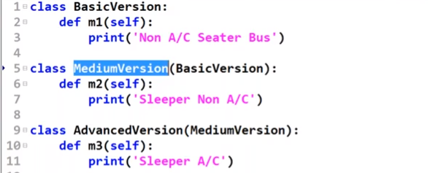

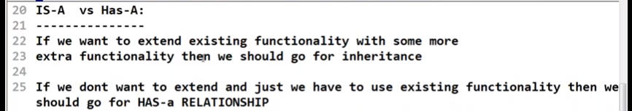
- Inner Class:

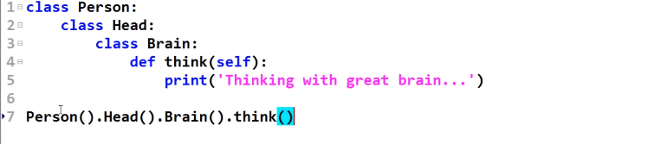

Testing in Python:
There are mainly 2 types of testing in Python:
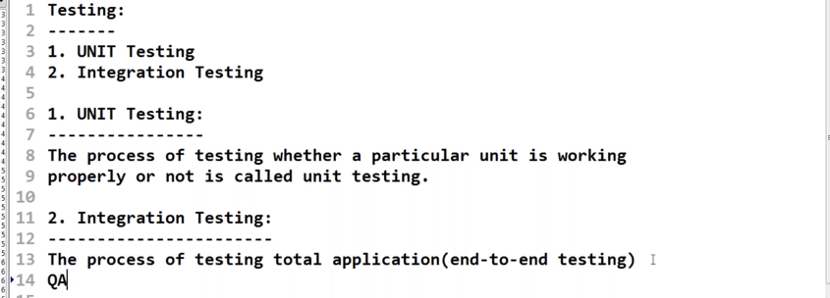

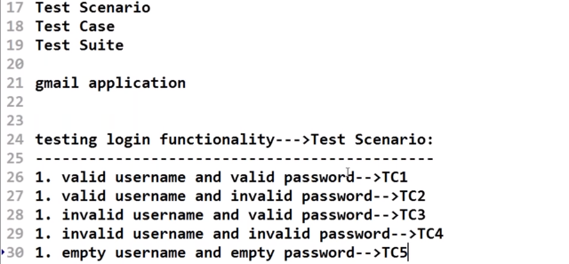

Group all these Test Cases & execute it is called as Test Suite

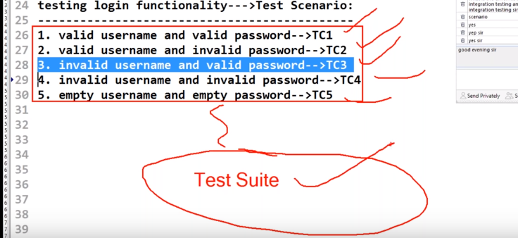
- Unit Testing

If I want to test the functionality of each individual unit of the Pen whether it is working properly or not.
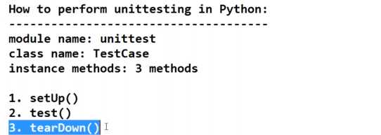
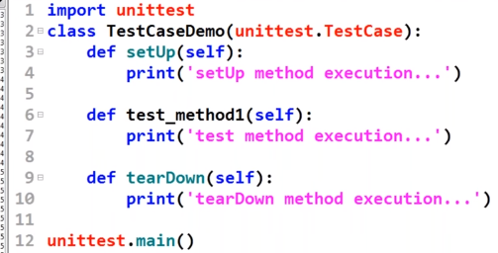

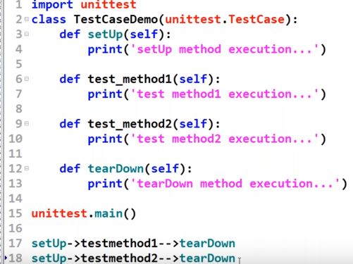
For every testmethod -- setup & teardown will be executed separately .
Output:
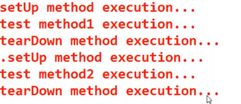

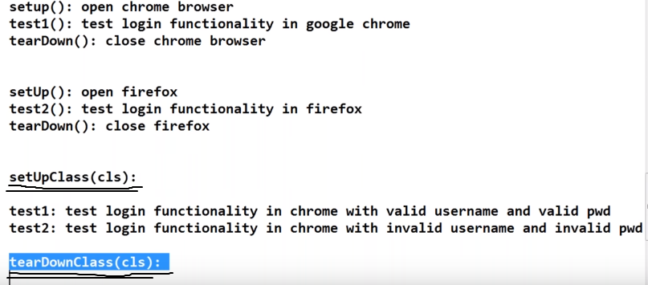

In setUpClass(cls): before executing test cases(here 2) setup class will be executed only once and after executing test cases tearDownClass(cls): will be executed only once.

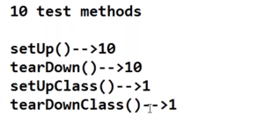

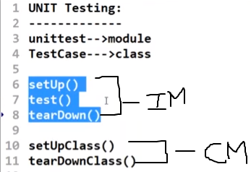

- Integration Testing



End to end testing of the product.

API:
- Two different applications can communicate with each other( Interoperability) .
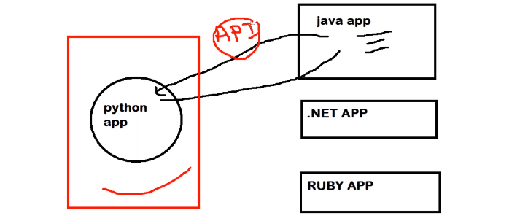
Web API/ Web Server:
- The common language to communicate between Python-Django is HTTP
- The common message format between these 2 are XML/JSON.They can share information using XML/JSON
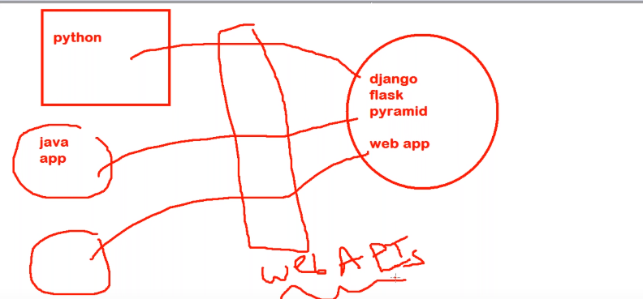

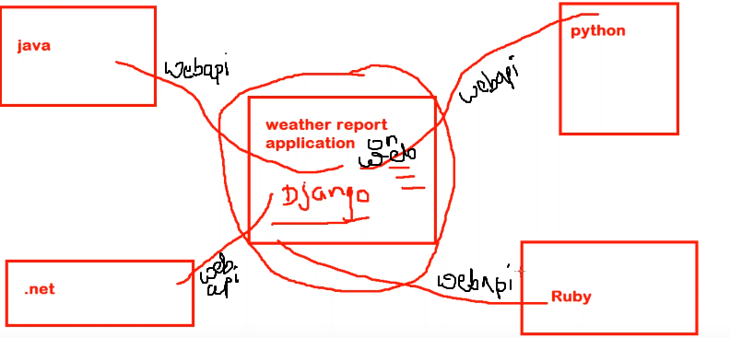

For loop in Python

computer_brands = ["Apple", "Asus", "Dell", "Samsung"]
for brands in computer_brands:
print brands

numbers = [1,10,20,30,40,50]
sum = 0
for number in numbers:
sum = sum + numbers
print sum

for i in range(1,10):
print i

for i in range(1,10):
if i == 3:
break
print i

for i in range(1,10):
if i == 3:
continue
print i

While Loop

The while loop tells the computer to do something as long as the condition is met
it's construct consists of a block of code and a condition.

It works like this: " while this is true, do this "

computer_brands = ["Apple", "Asus", "Dell", "Samsung"]
i = 0
while i < len(computer_brands):
print computer_brands(i)
i = i + 1

while True:
answer = raw_input("Start typing...")
if answer == "quit":
break
print "Your answer was", answer

counter = 0
while counter <= 100:
print counter
counter + 2

3.Nested Loops

for x in range(1, 11):
for y in range(1, 11):
print '%d * %d = %d' % (x, y, x*y)

Basic Functions:
df.head(n) - First n rows of the
df.tail(n) - Last n rows of the
df.shape() - Number of rows and columns / array= x.shape ( x[start:stop:step])
df.info() - Index, Datatype and Memory information
df.describe() - Summary statistics for numerical columns
df.value_counts(dropna=False) - Views unique values and counts
df.apply(pd.Series.value_counts) - Unique values and counts for all columns
srting_outcome = str(numeric_input)
integer_outcome = int(string_input)
float_outcome = float(string_input)
type(var_name)

import pdb; pdb.set_trace()

Command | Short form | What it does
args | a | Print the argument list of the current function
break | b | Creates a breakpoint (requires parameters) in the program execution
continue | c or cont | Continues program execution
help | h | Provides list of commands or help for a specified command
jump | j | Set the next line to be executed
list | l | Print the source code around the current line
next | n | Continue execution until the next line in the current function is reached or returns
step | s | Execute the current line, stopping at first possible occasion
pp | pp | Pretty-prints the value of the expression
quit or exit | q | Aborts the program
return | r | Continue execution until the current function returns

Git Python commands:
1. git init: Initialized empty Git repository
2. git status
3. git add hello.py – Add to Version Control System
4. git commit -m "creating hello.py" -commiting changes
5. git add .gitignore –
git commit -m "created .gitignore"
6. git log – Check the log
7. git checkout master
8. git show-branch
9. git clone

4.User defined functions:
Example1: To draw histogram
def draw_histograms(dataframe, features, rows, cols):
fig=plt.figure(figsize=(20,20))
for i, feature in enumerate(features):
ax=fig.add_subplot(rows,cols,i+1)
dataframe[feature].hist(bins=20,ax=ax,facecolor='midnightblue')
ax.set_title(feature+" Distribution",color='DarkRed')

fig.tight_layout()
fig.savefig('C:/Users/chetan_shekdar/Desktop/Projects/Heart Disease/Heart_Disease.png')
plt.close(fig)

draw_histograms(heart_df,heart_df.columns,6,3)

Example 2: Feature Selection: Backward elimination (P-value approach)

def back_feature_elem (data_frame,dep_var,col_list):
""" Takes in the dataframe, the dependent variable and a list of column names, runs the regression repeatedly eleminating feature with the highest
P-value above alpha one at a time and returns the regression summary with all p-values below alpha"""

while len(col_list)>0 :
model=sm.Logit(dep_var,data_frame[col_list])
result=model.fit(disp=0)
largest_pvalue=round(result.pvalues,3).nlargest(1)
if largest_pvalue[0]<(0.05):
return result
break
else:
col_list=col_list.drop(largest_pvalue.index)

result=back_feature_elem(heart_df_constant,heart_df.TenYearCHD,cols)

result.summary()
result.params

Example3: missing sum
def num_missing(x):
return sum(x.isnull())
#Getting count of "NaN"-Method1
count_nan = len(data) - data.count()

#Getting count of "NaN"-Method2
null_columns=data.columns[data.isnull().any()]
data[null_columns].isnull().sum()

total = train.isnull().sum().sort_values(ascending = False)
percent = round(train.isnull().sum().sort_values(ascending = False)/len(train)*100, 2)
pd.concat([total, percent], axis = 1,keys= ['Total', 'Percent'])

Exapmle4: Frequency Table
train[['Pclass', 'Survived']].groupby("Pclass").mean()

survived_summary = train.groupby("Survived")
survived_summary.mean()

Example5: Apply function on each row of the column of the datasets

train['name_length'] = [len(i) for i in train.Name]
test['name_length'] = [len(i) for i in test.Name]

Example6: Creating Dummies
def name_length_group(size):
a = ''
if (size <=20):
a = 'short'
elif (size <=35):
a = 'medium'
elif (size <=45):
a = 'good'
else:
a = 'long'
return a

train['nLength_group'] = train['name_length'].map(name_length_group)
test['nLength_group'] = test['name_length'].map(name_length_group)

Example7: Display limited columns of the dataframe:
pd.options.display.max_columns = 99
train.head()

Example8: Frequency table
spf_summary=pd.crosstab(index=phish_df["spf"],columns="count")
print(spf_summary)

Example9: Extracting multiple items from list
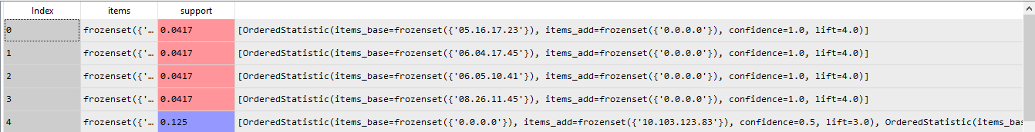
final_result = []
for result in association_results:
final_result.append({
"ip_list" : list(list(result)[0]),
"support" : list(result)[1],
"confidence" : list(list(result)[2][0])[2],
"lift" : list(list(result)[2][0])[3]})

Example10: Parsing Sets
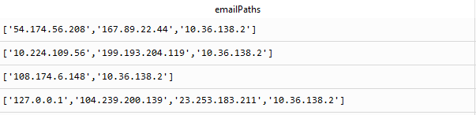
tempmasterList = np.array(df["emailPaths"])
masterList =[]
for x in tempmasterList:
x = x.replace("[","").replace("\'","").replace("]","")
x =x.split(",")
strs= ''
for zz in x:
strs=strs+"_"+zz.strip()
masterList.append(strs[1:len(strs)])
masterList

Example11: Selecting desired columns:
Df = bottom5_approach.loc[:, ['emailPaths','flag']]

Example12: Fill missing
meadian_value=train['Age'].median()
train['Age']=train['Age'].fillna(median_value)

Example13: Target flagging:

df_quick_data['Target']=df_quick_data['Renewal Type'].apply(lambda x: 1 if x in ['Early Renewal','On Time'] else 0)

Example14: Get dummies
df_quick_data=pd.get_dummies(df_quick_data,columns=['EC DP Account Segmentation',
'NACR Platform NGS','Sales Area',
'Sales Geography','Range Code'])

Example15: Drooping column
df.drop(columns=['Target'],inplace=True) OR
df_quick_data.drop(['Target'],inplace=True,axis=1)
# keep desired columns
df1 = df[['a','d']]

OR
to_remove = ['timestamp','process_id']
train_df = train_df[train_df.columns.difference(to_remove)]
test_df= test_df[test_df.columns.difference(to_remove)]

Example16: Subsetting variables.
features_to_use = [e for e in columns if e not in ('Renewal Type',)]

Example17: Target variable count columnwise
test_age = df.groupby(['Contract Opportunity Qtr','Serial Num Age', 'Target']).size()

Example18: Delete NaN rows
df = df[np.isfinite(df['EPS'])]

Example19: Counting zeros row wise and drooping
np.sum((booking_amount['USD Booking Amount'] < 0).values.ravel())
booking_amount = booking_amount.ix[booking_amount['USD Booking Amount'] >= 0]

Example20: Extract part of the string row wise
def extract3Letters(var):
x= var[0:3]
return x

df['NACRPlatformNGS_flag'] = df['NACR Platform NGS'].map(extract3Letters)

Example21: Select rows whose column value equals a scalar
df.loc[df['column_name'] == some_value]

Example22: Pivot Table
target_dist= data.pivot_table(values='EC DP Account Segmentation', index='Contract Opportunity Qtr', columns='Renewal Type', aggfunc=np.size)

.
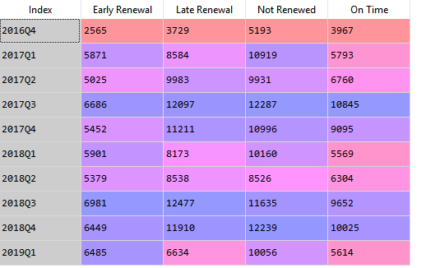

Example23: Pivot Table

booking_amount['USDBookingAmount_flag1'] = booking_amount['USDBookingAmount_flag']#VeryImportant
target_dist= booking_amount.pivot_table(values='USDBookingAmount_flag', index=['Contract Opportunity Qtr','USDBookingAmount_flag1'], columns='Target', aggfunc=np.size)

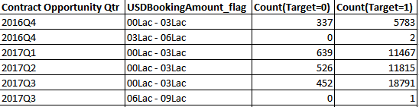

Example24: Graphs in loop
# multiple line plot
for column in df.drop('x', axis=1):
plt.plot(df['x'], df[column], marker='', color='grey', linewidth=1, alpha=0.4)

Example25: Memory usage
gl.info(memory_usage='deep')

Example26: Flagging a variable:
bottom5_approach['flag'] = [ 1 if i > 0 else 0 for i in bottom5_approach.flag_]

Example27: plot minutes on X-axis
ax1.xaxis.set_major_locator(mdates.MinuteLocator(interval=5)) #to get a tick every 15 minutes
ax1.xaxis.set_major_formatter(mdates.DateFormatter('%H:%M:%S'))

Example28: Reading image
from PIL import Image
import numpy as np
img = Image.open('lena_bw.jpg')
import matplotlib.pyplot as plt
import matplotlib.image as mpimg
import os
os.chdir('C:\\Users\\chetan_shekdar\\Desktop')
img=mpimg.imread('cat.jpg')
imgplot = plt.imshow(img)

Example29: Train and Test Accuracy
print "Train Accuracy :: ", accuracy_score(train_y, trained_model.predict(train_x))
print "Test Accuracy :: ", accuracy_score(test_y, predictions)

Example30: Creating lags in loop
features= ['AmbientTemp','Humidity','Speed','Temperature']
lag = [1,2,3,4]
for var in features:
for l in lag:
df.loc[:,var+"_lag"+str(l)] = df[var].shift(l)

Q: Map this logic to SROMPipeline:
